**Name – Sarah Thomas**

**Reg. No: 23BSA10160**

**Subject: CSE3015 AWS Cloud Practitioner  
Slot: A11+A12+A13**

**Date: 28-07-2025**

**Assignment 3   
Create EC2 instance with Ubuntu AMI and using PuTTy.**

1. Log in to the AWS Console.

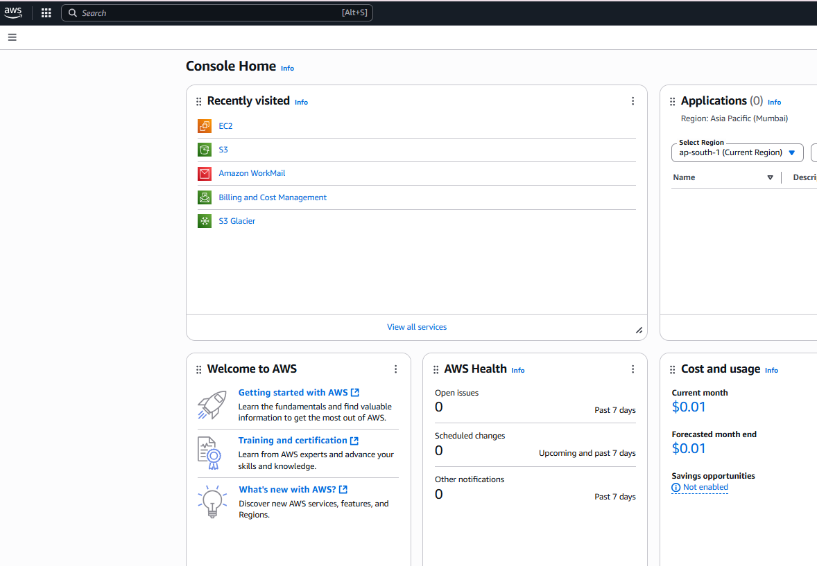

1. Navigate to Services -> Compute -> EC2.

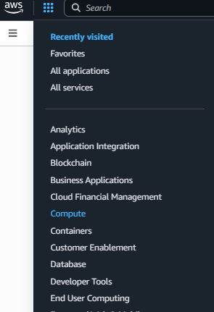

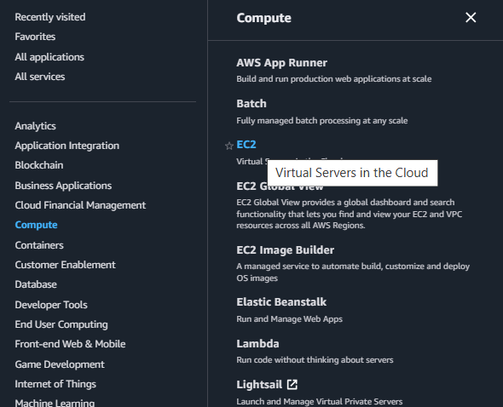

1. Click on Launch Instance.

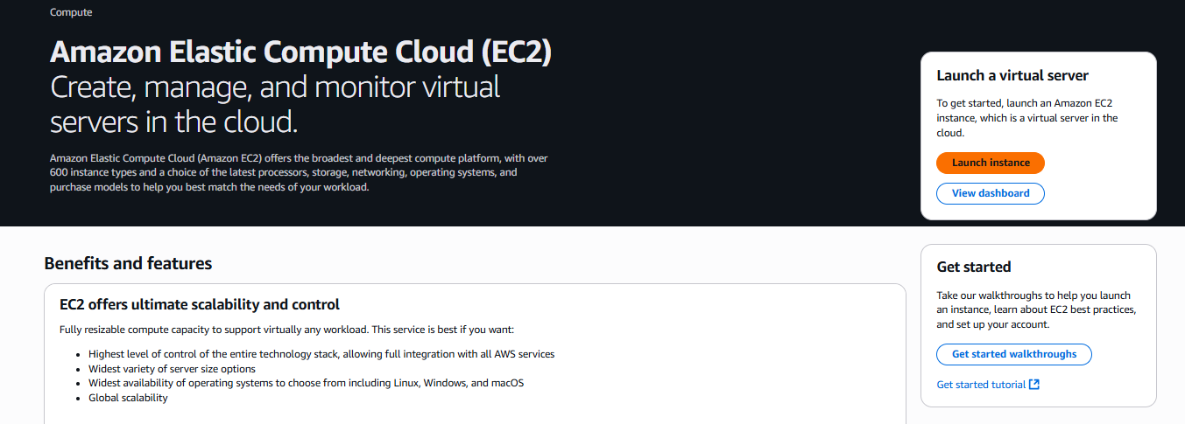

1. Give name to the web server.

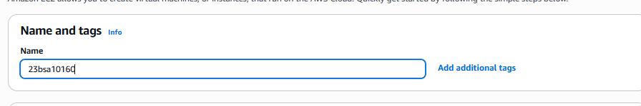

1. Select AMI(Amazon Machine Image) in this case Ubuntu.

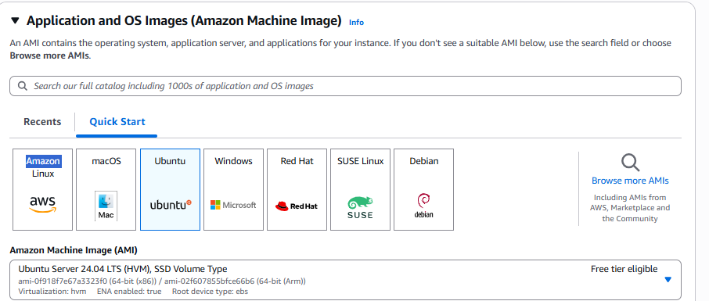

1. Select the Instance type as either t2.micro or t3.micro.

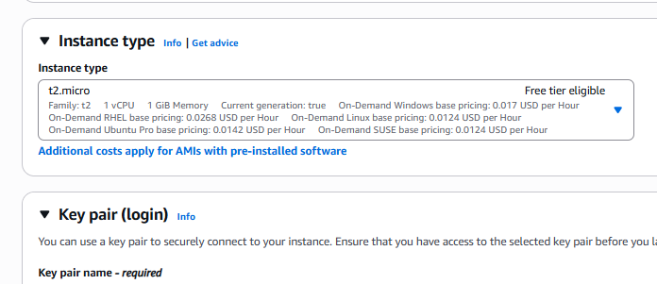

1. Create the appropriate key pair and save it in .pem format.  
   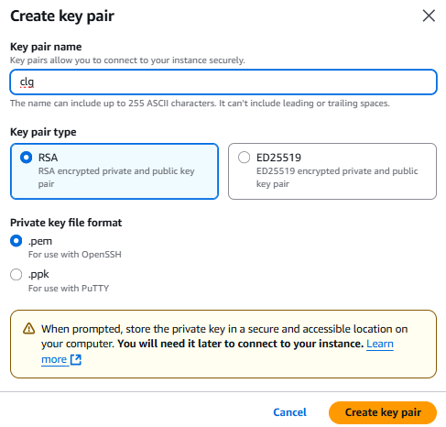
2. Under Network settings, allow HTTP and HTTPS access.  
   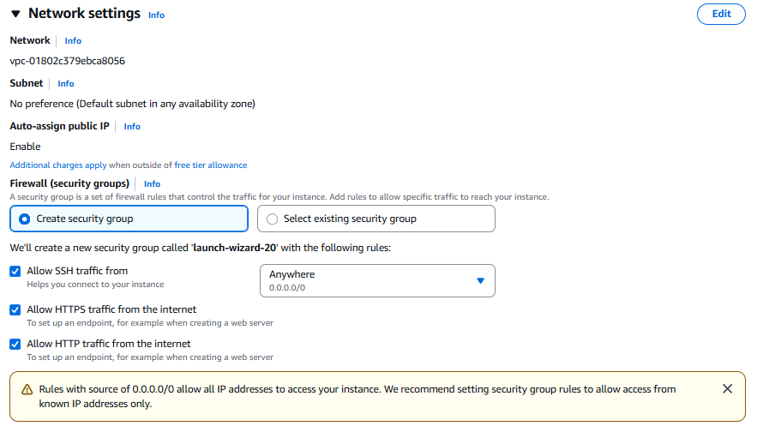
3. Set the Storage Settings as default and the then Launch the Instance.  
   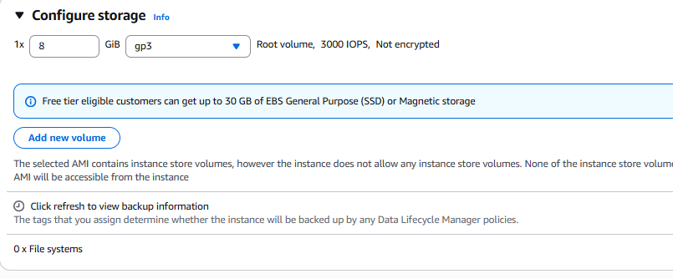

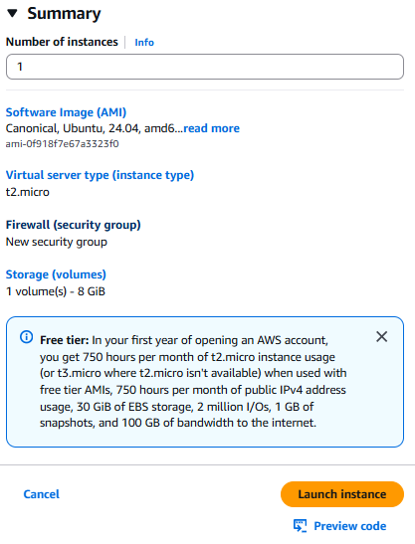

1. Go to instances and wait until it shows 2/2 check.  
   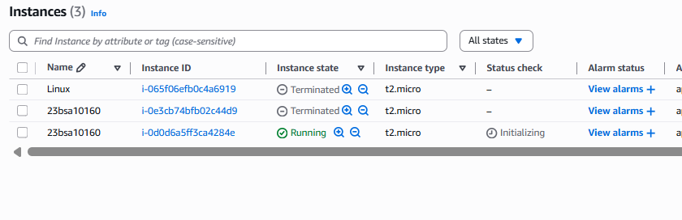
2. Open PuTTygen application to create .ppk file.  
   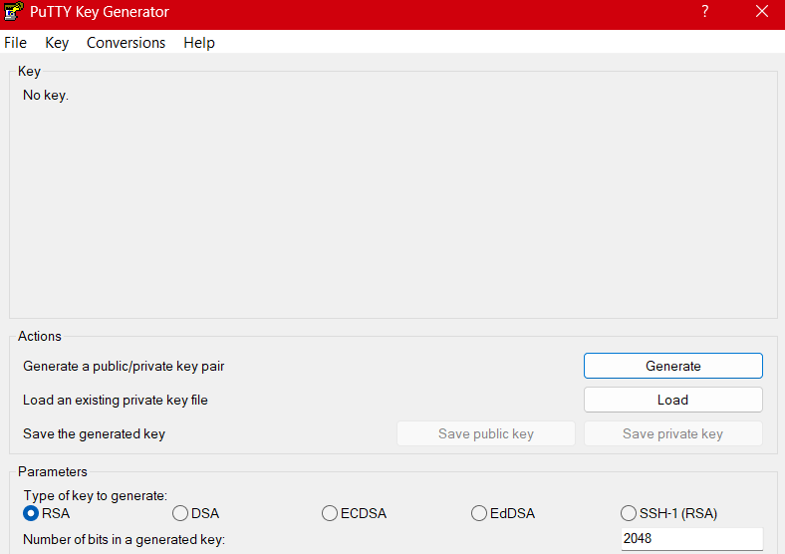

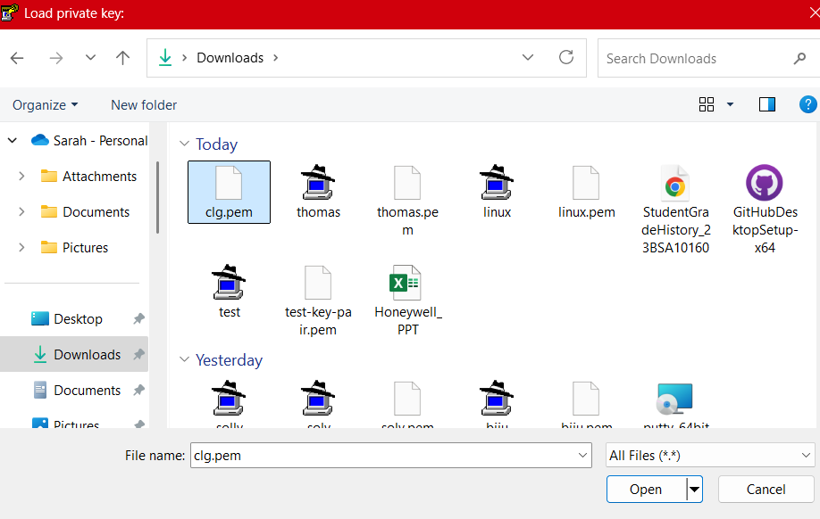

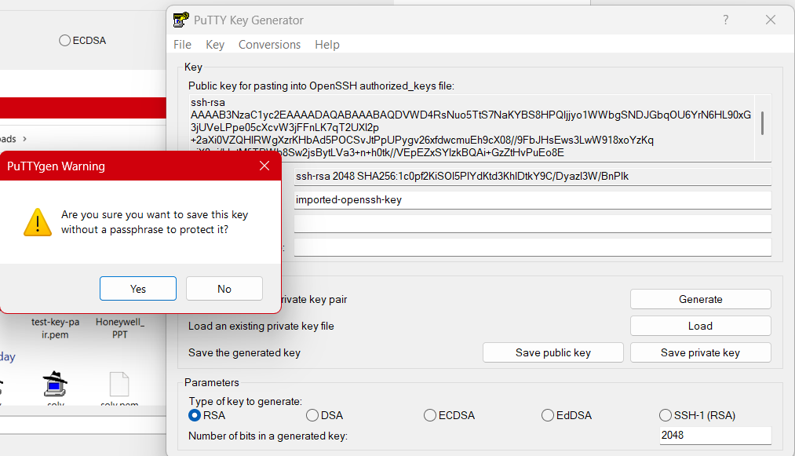

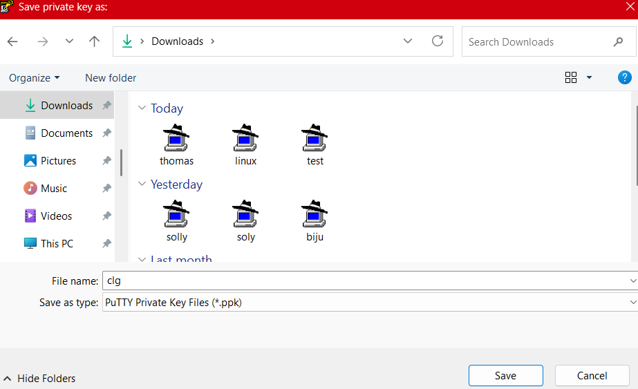

1. Once 2/2 check is done, click on the instance and copy its Public IP address.  
   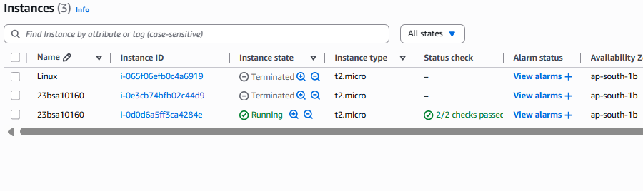

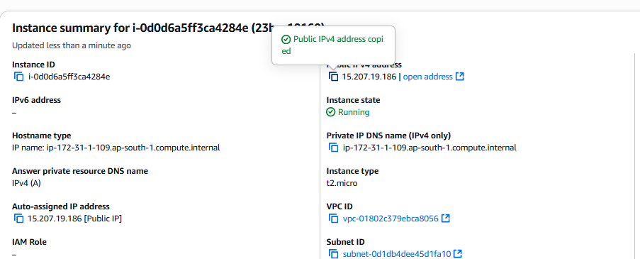

1. Open PuTTy application.  
   Enter Host Name or Public IP Address.  
   Connection -> SSH -> Auth -> Credentials -> Browser and all the .ppk.  
   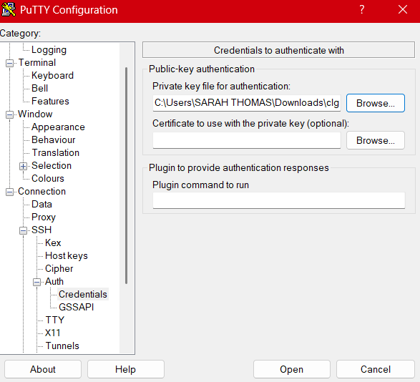
2. Once the server starts, login as “ubuntu”.  
   Execute the below code in the server.  
   sudo apt update  
   sudo apt install apache2 -y

sudo service apache2 start

sudo service apache2 status

1. The run the IP address in the web browser, the below message pops on the screen.  
     
   